SIMATS ENGINEERING
ASSESSMENT TOOL 2

COURSE NAME: Database Management Systems
COURSE CODE: CSA0501

COURSE OUTCOME COVERED

CO1: Analyze DBMS architecture, different data models, schema types, and design ER/EER diagrams, relational schemas for case-based scenarios by identifying entities and relationships. (BL1, BL2)

Activity Tool : Concept Mapping (Medium)
Assessment Tool Weightage: 35%

Dr

QUESTIONS Total Marks: 50
Q.No | Question | Bloom's Level | Marks
1 | Construct a concept map linking the following terms: DBMS, Schema, Instance, Data Model, ER Diagram, Entity, Attribute, Relationship. | BL2 – Understand | 5
2 | Create a concept map for the three-level ANSI/SPARC architecture showing data independence at each level. | BL2 – Understand | 5
3 | Map the relationship between file-based systems and database systems, highlighting the problems solved by DBMS. | BL2 – Understand | 5
4 | Design a concept map for ER diagram components: entity, weak entity, attribute types, relationship types, and participation constraints. | BL2 – Understand | 5
5 | Construct a concept map comparing Hierarchical, Network, and Relational data models with their key properties. | BL2 – Understand | 5
6 | Develop a concept map for the EER model showing how it extends the basic ER model with generalization, specialization, and aggregation. | BL2 – Understand | 5
7 | Create a visual concept map for the DBMS software architecture, illustrating the flow from user request to data retrieval. | BL2 – Understand | 5
8 | Map the data models discussed in CO1 to real-world applications and explain the suitability of each model. | BL2 – Understand | 5
9 | Construct a concept map for schemas and instances, showing how they relate to physical and logical data independence. | BL2 – Understand | 5
10 | Design a concept map for the roles and responsibilities in a DBMS environment: DBA, End User, Application Developer. | BL1 – Remember | 5

Code of Conduct:

I K. Saranya (192424409)(Name / Reg No) certify that this submission is my original work and that I have adhered to the guidelines specified for this assessment.
I understand that any violation of academic integrity rules will result in disciplinary action.

K.saranya
Signature of the student:

RUBRICS FOR CALCULATION:

Criteria | Weightage | Level 4 (Exemplary) | Level 3 (Proficient) | Level 2 (Developing) | Level 1 (Beginning)
Concept Identification | 25% | Identifies all key concepts from literature accurately and comprehensively | Identifies most key concepts with minor omissions | Identifies limited concepts; some are irrelevant or missing | Fails to identify essential concepts
Linkages | 25% | Establishes clear, meaningful, and accurate relationships between concepts | Shows correct relationships with minor gaps | Relationships are weak, unclear, or partially incorrect | No meaningful relationships established
Organization | 20% | Concepts are well-structured hierarchically with logical flow and grouping | Mostly organized with minor structural issues | Some organization but lacks clear hierarchy | No logical organization or structure
Integration of Literature | 20% | Integrates multiple studies effectively to show connections and comparisons | Shows some integration of literature | Limited integration; mostly isolated concepts | No integration of literature evidence
Clarity | 10% | Concept map is clear, neat, visually structured, and easy to interpret | Generally clear with minor readability issues | Clarity is reduced; difficult to interpret in parts | Poorly presented and hard to understand

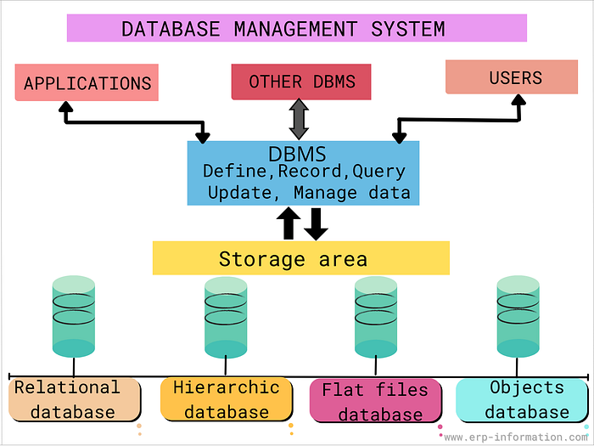

How to read these concept maps
Each map uses a consistent colour code so relationships stay easy to trace across all ten questions:
Root / central concept
Primary branch concept
Supporting sub-concept (teal-green)
Contrast / problem-solution branch
Constraint or rule node

Q1. DBMS, Schema, Instance, Data Model, ER Diagram, Entity, Attribute, Relationship
A DBMS is described by a Data Model, organized through a Schema (the stable, overall design). The Schema's actual data at a point in time is called an Instance. The Data Model is visualised through an ER Diagram, which represents Entities, their Attributes, and the Relationships connecting them.
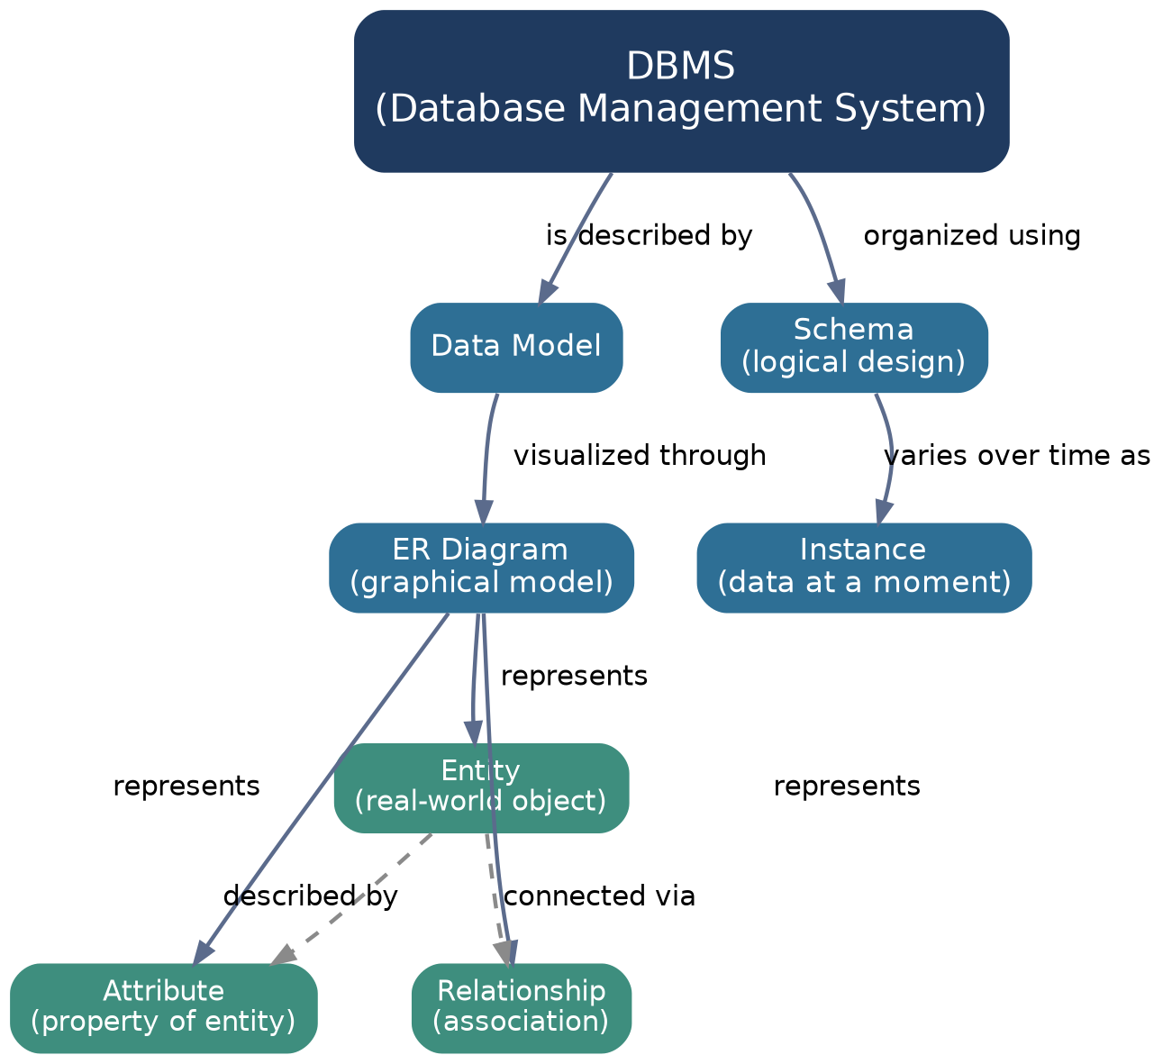
Figure 1: Concept map for Question 1

Q2. Three-Level ANSI/SPARC Architecture & Data Independence
The architecture separates the External level (user views), Conceptual level (community-wide logical view), and Internal level (physical storage). Logical Data Independence shields external views from conceptual-level changes; Physical Data Independence shields the conceptual level from internal storage changes.
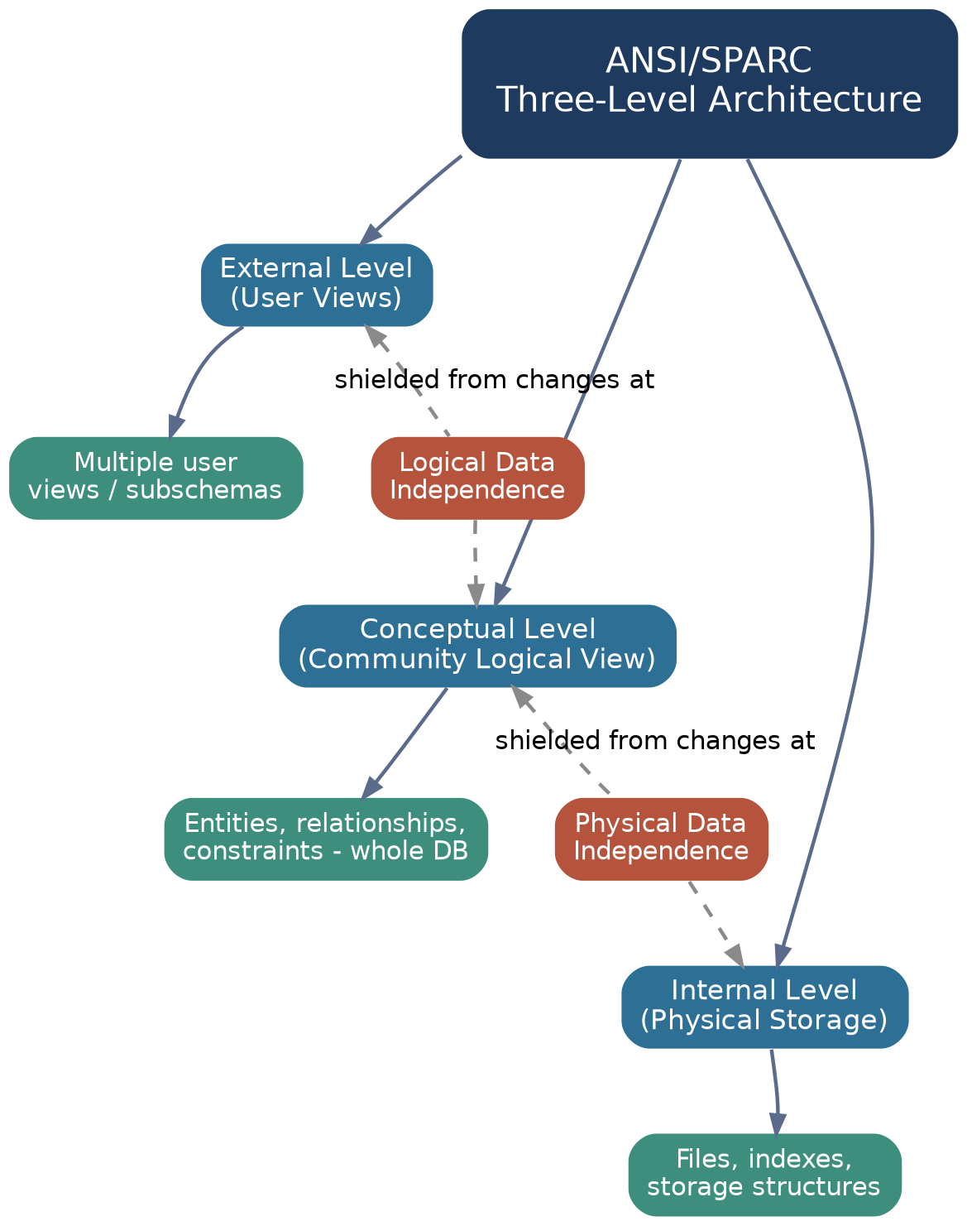
Figure 2: Concept map for Question 2

Q3. File-Based Systems vs Database Systems
Traditional file-based systems suffer from redundancy, difficult access, isolated data, weak integrity, poor concurrency control, and weak security. A DBMS solves each of these problems directly, as mapped below, and delivers a single centralized, reliable database system.
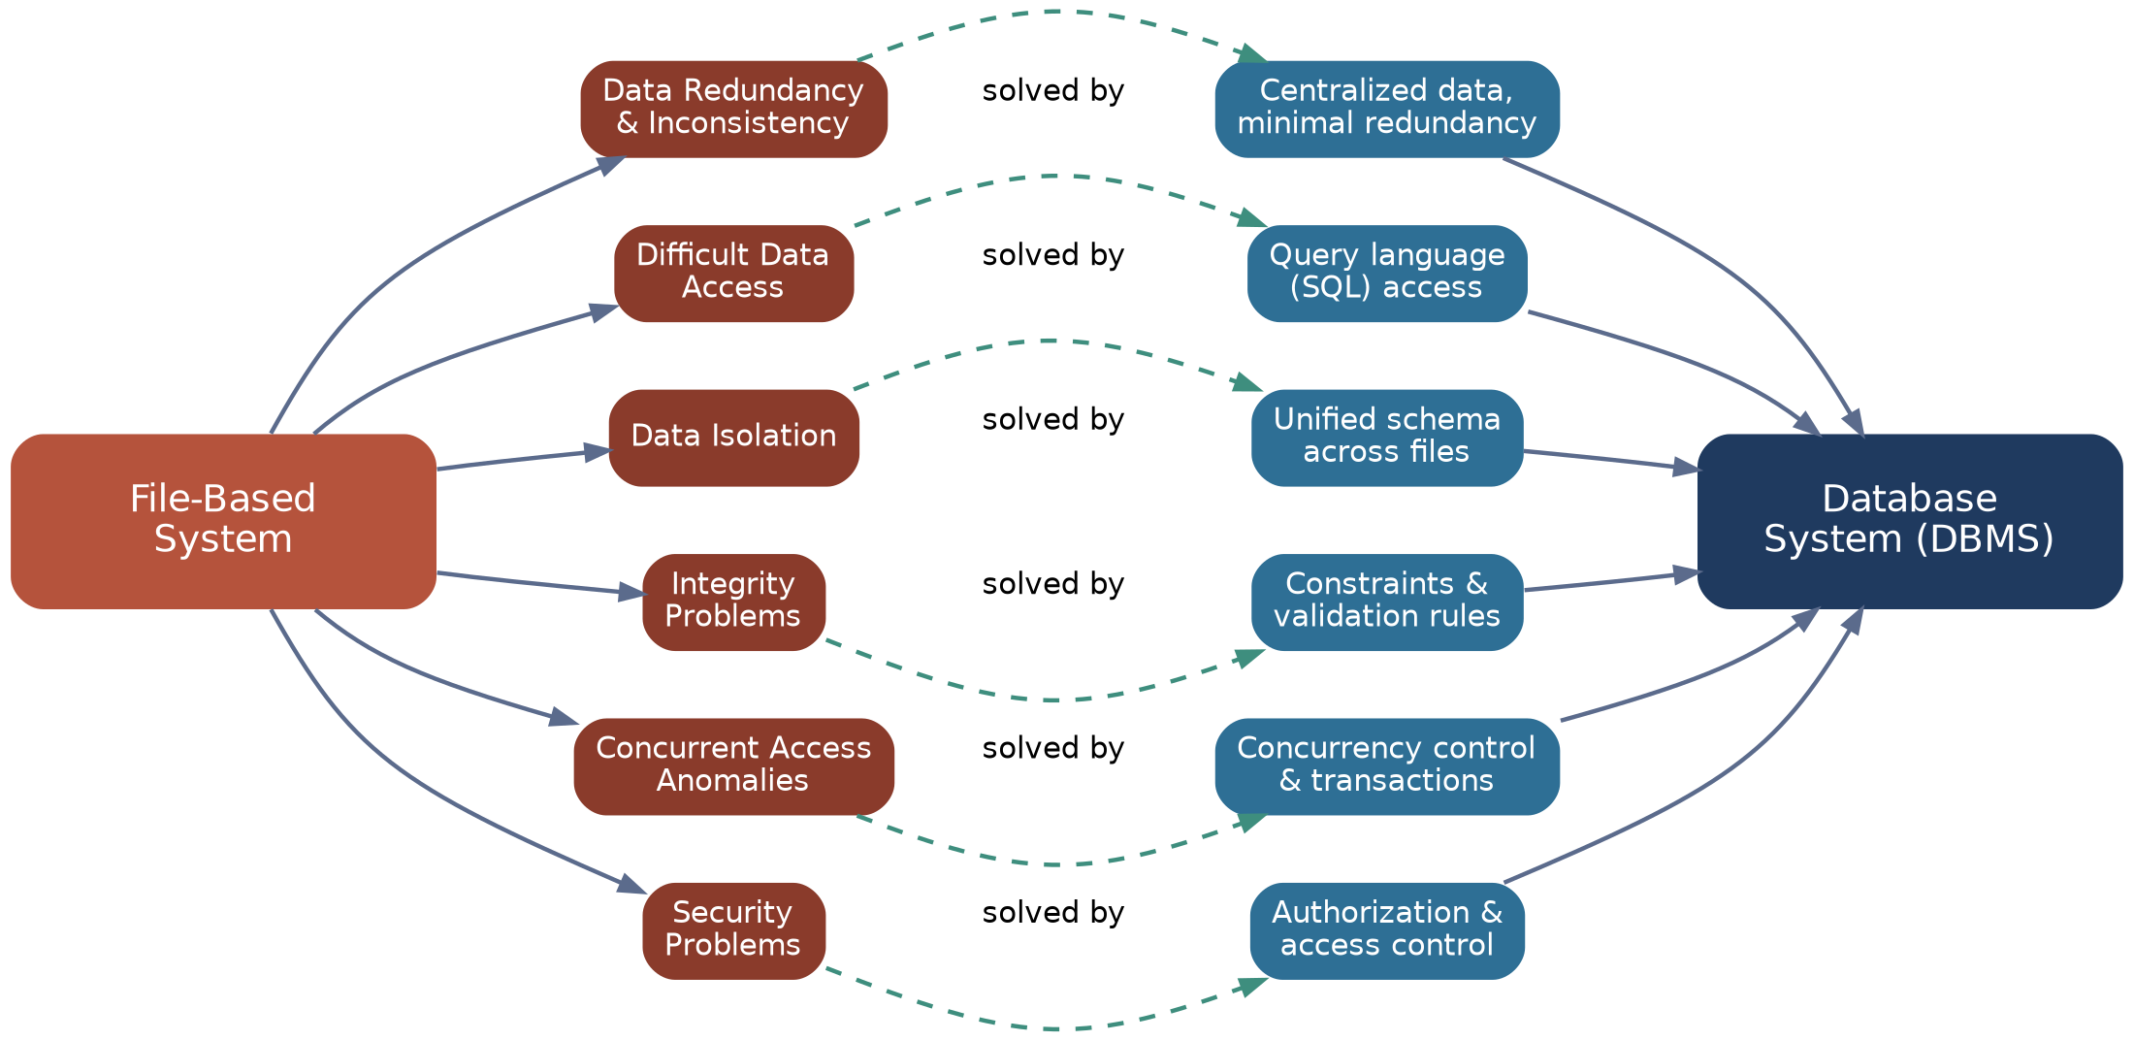
Figure 3: Concept map for Question 3

Q4. ER Diagram Components
An ER diagram is built from Entities (Strong/Weak), Attributes (Simple, Composite, Derived, Multivalued), Relationships (Unary, Binary, Ternary based on degree), and Participation Constraints (Total/mandatory or Partial/optional) that define how entities take part in relationships.
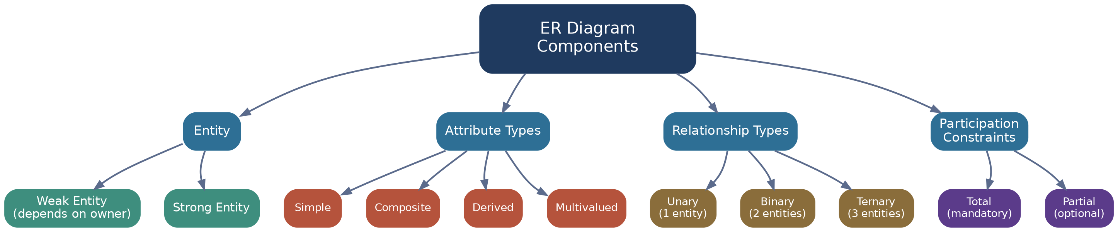
Figure 4: Concept map for Question 4

Q5. Hierarchical vs Network vs Relational Data Models
The Hierarchical model uses a rigid parent-child tree (1:N); the Network model uses a flexible owner-member graph supporting M:N links; the Relational model organizes data into tables and uses SQL with strong support for normalization -- the most widely used model today.
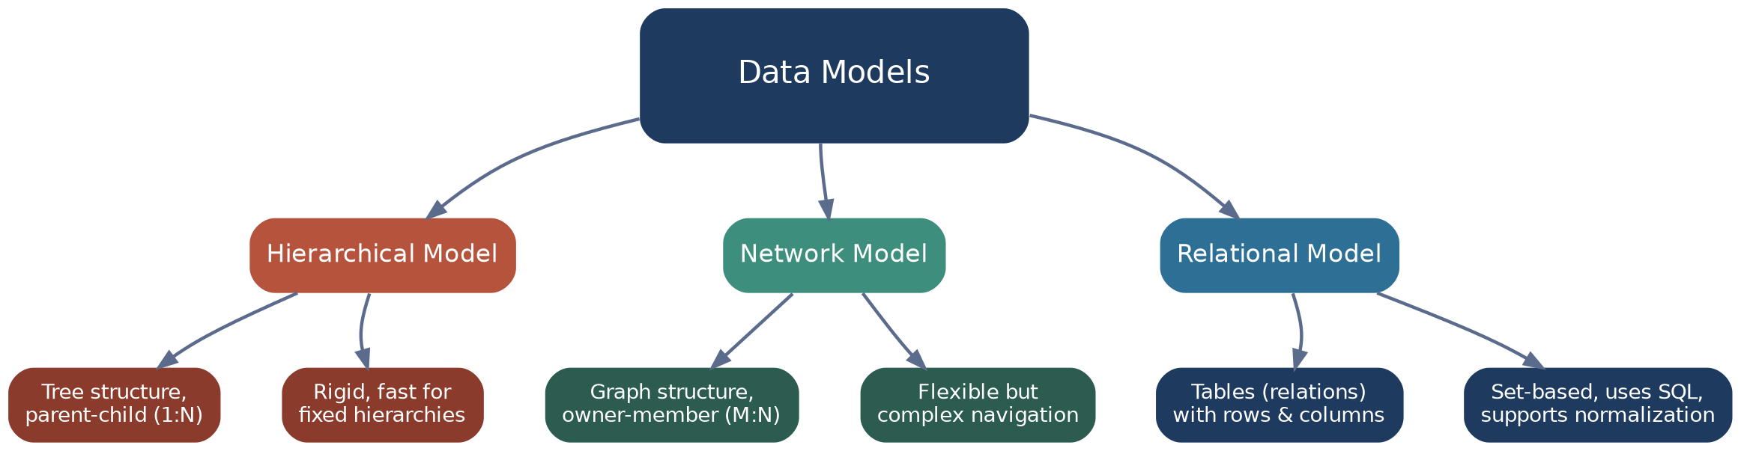
Figure 5: Concept map for Question 5
Q6. EER Model - Generalization, Specialization & Aggregation
The Enhanced ER (EER) model extends the basic ER model with Generalization (combining similar subtypes bottom-up into a supertype), Specialization (dividing a supertype top-down into subtypes), and Aggregation (treating a relationship itself as a higher-level entity), governed by disjoint/overlapping and total/partial constraints.
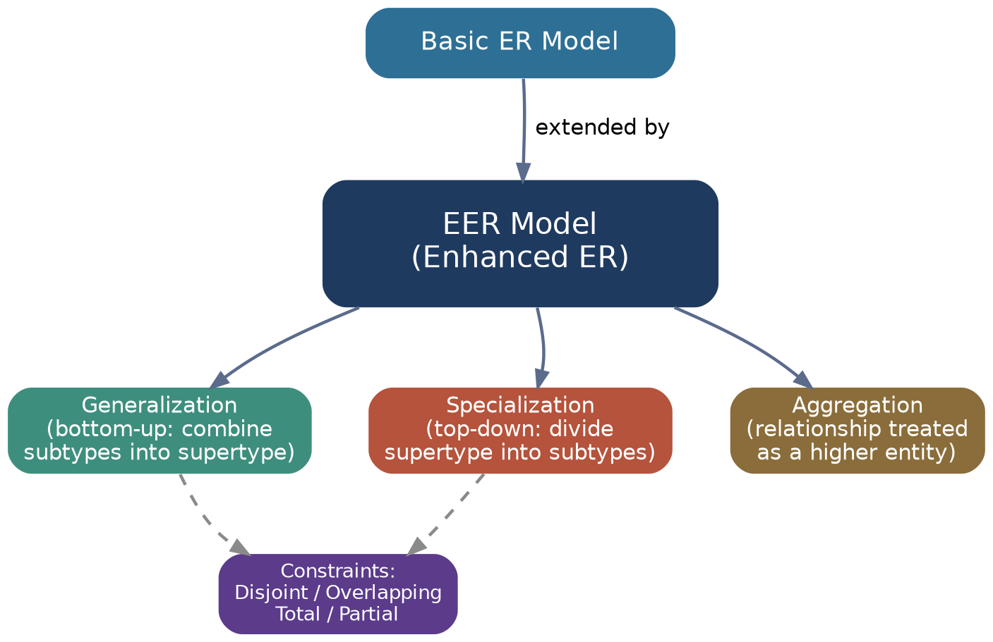
Figure 6: Concept map for Question 6

Q7. DBMS Software Architecture - Request to Retrieval
A user's SQL query passes through the Query Processor (parsing), the Query Optimizer (best execution plan), the Execution Engine, and the Storage Manager, which reads/writes the physical database files and returns data blocks back up the chain as a formatted result.
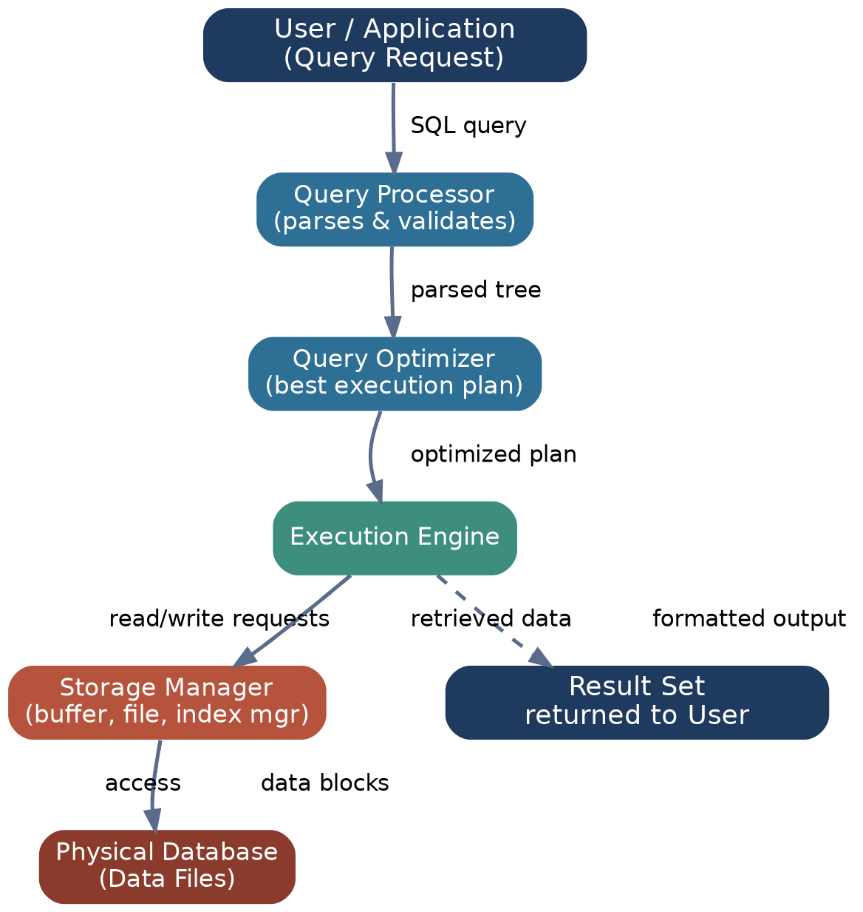
Figure 7: Concept map for Question 7

Q8. Data Models Mapped to Real-World Applications
The Relational model suits structured, consistency-critical systems (banking, ERP, HR); the Hierarchical model suits clear parent-child data (file systems, XML/JSON, org charts); the Network model suits many-to-many links (reservations, inventory); and Object-Oriented/NoSQL models suit flexible, unstructured, real-time data (social media, IoT).
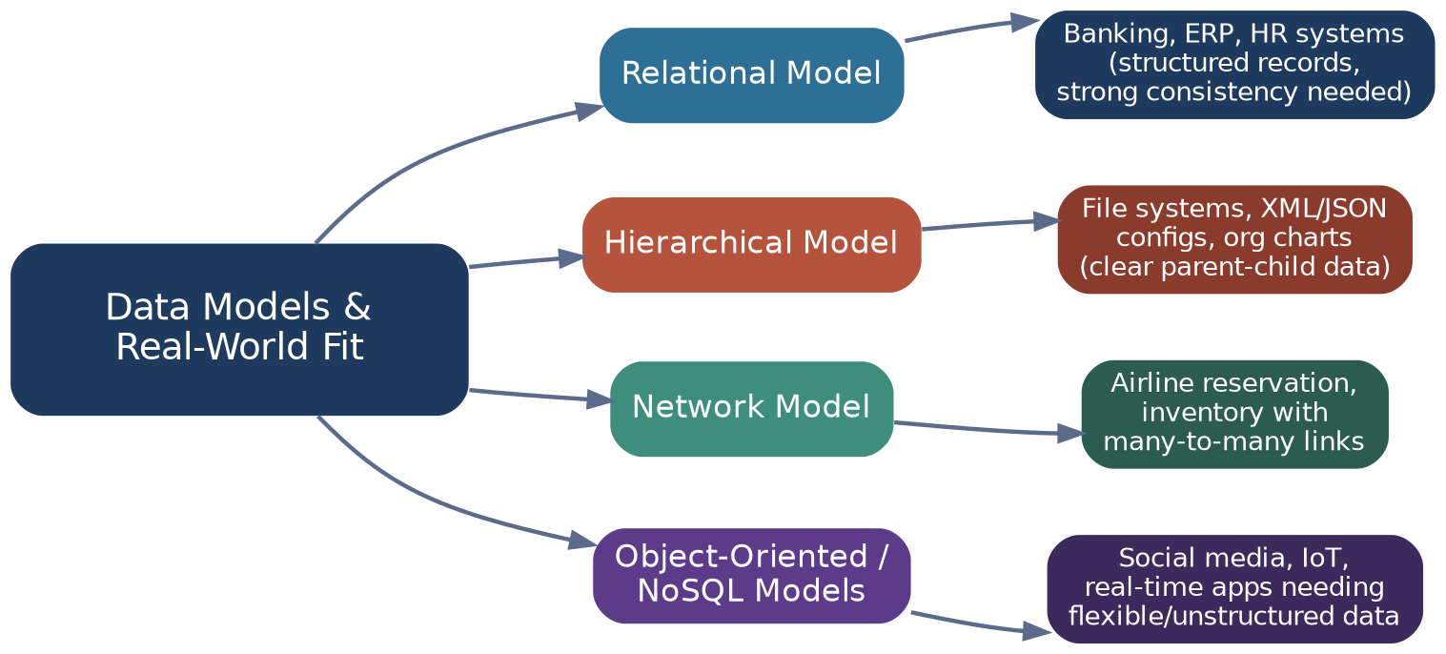
Figure 8: Concept map for Question 8
Q9. Schema & Instance vs Physical/Logical Data Independence
The Schema is the stable overall design, further split into a Logical Schema (conceptual level) and a Physical Schema (internal/storage level), while the Instance is the actual data at a moment. Logical Data Independence hides logical-schema changes from external views; Physical Data Independence hides storage changes from the logical schema.
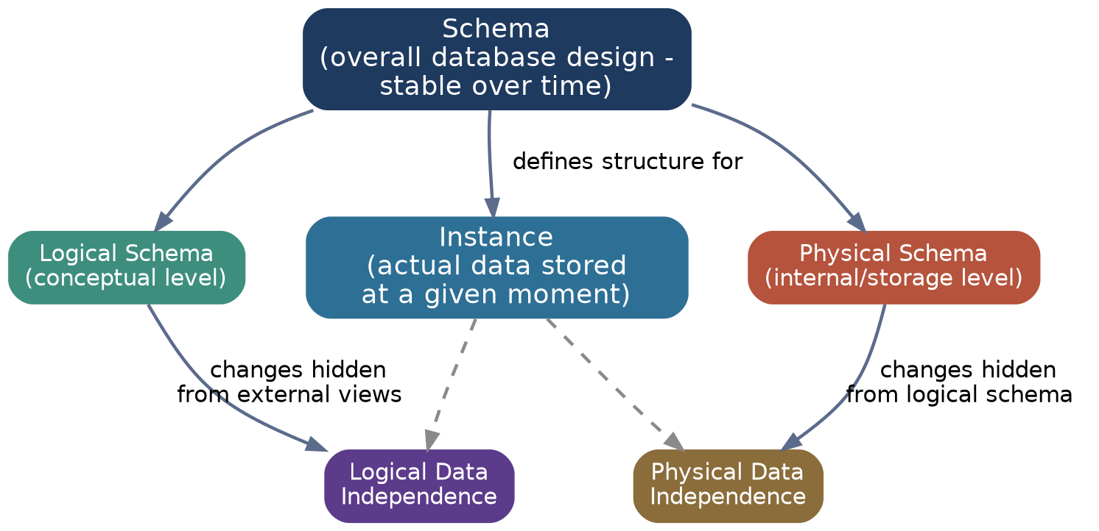
Figure 9: Concept map for Question 9
Q10. Roles & Responsibilities in a DBMS Environment
The Database Administrator (DBA) defines schemas, manages security, backup, recovery and performance; the Application Developer builds programs, forms and reports using DML/APIs; and End Users interact with the system either as casual users running ad-hoc queries or as naive/parametric users running fixed transactions.
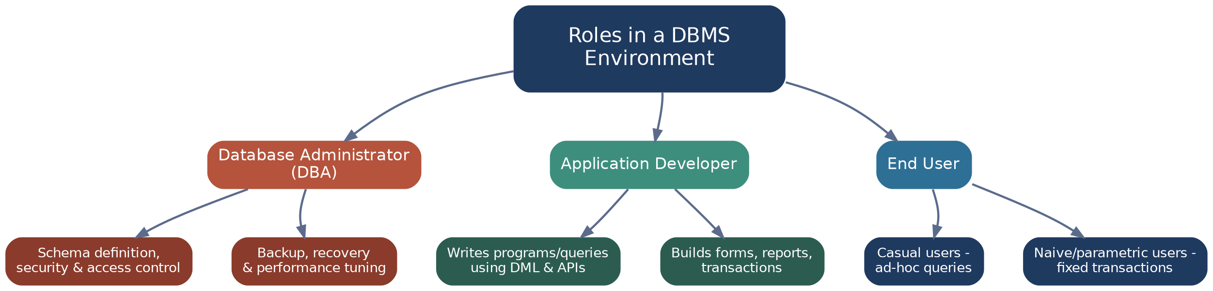
Figure 10: Concept map for Question 10

